Staff Support Service

More on Prosocial background attachment.

**Staff Feedback from Involvement:**

I’m Sue, and have been a Renal Doctor in D&G for 30 years, during COVID I was deployed into the Combined Assessment Unit and got involved with SWEETS.

In D&G we were lucky our clinical psychology team decided to redeploy their staff and time to support staff during this difficult time. I got involved to open doors with different staff groups, as they talked staff through the potential psychological impact and what staff could do to support themselves. As well as launching the Staff Support Button on our intranet, with a host of psychological support resources, links and self help tips.

There was access to the level of psychological support you needed when you needed it, and this was the first time we had ever had anything like that.

The impact on staff knowing that was there for them was huge, we are very aware that our acute system is difficult work in and staff have felt very much under pressure and have struggled psychologically. Here we had a huge threat to our society, families, loved ones, colleagues, and patients and the organisation stepped up and provided that support. And acknowledged this wasn’t going to be for a few weeks but needed for a longer term. I think the feeling for the staff of being valued by the organisation and having this set up for them was priceless. Something I was very proud to be involved with, I learnt a lot and gained a lot psychological support myself from this and SWEETS.

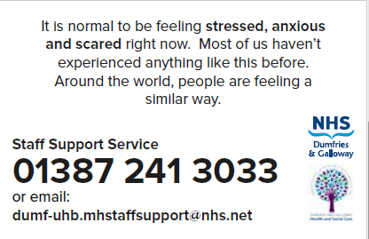

**Staff Feedback from accessing support:**

I was made aware of the staff wellbeing service in the early stages of the Covid outbreak when Rab came along the corridor and introduced himself, telling myself and my colleagues about the services available to support us. His visit was the only reason I felt comfortable speaking with him about needing help - I wouldn't have called the phone number or approached anyone about my issues otherwise.

During our first conversation Rab put me completely at ease and I genuinely felt supported and listened to, this was at a time in my life when I wasn't sure if I'd even be able to get through the day and felt as though I had absolutely no-one to talk to. I couldn't have felt more supported by him and he really took the time to understand my situation and get me talking and thinking about what I needed help with the most. Over the course of our next few sessions Rab took me through things he thought would help and we discussed the practical applications of the theories he suggested. Without these chats I have absolutely no doubt I'd have ended up being off work with stress, anxiety and burnout. The tools he taught me have really helped and I can honestly say I feel so much better than this time a few weeks ago. I can't recommend Rab and the wellbeing service enough and I'm really glad he was there when I needed help.

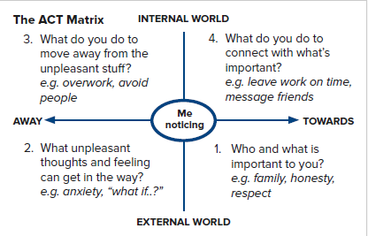

There is now a group of Psychology and ODL staff undertaking their Pro social training through prosocial.world, Professor Paul Aitkins to further develop the use of the prosocial model in D&G